# **PROJECT REPORT**

# **CRM APPLICATION FOR SCHOOLS/COLLEGES**

## **1.INTRODUCTION**

This project report describes the development of a custom Customer Relationship Management (CRM) application for schools and colleges using Salesforce. The objective of this project is to provide educational institutions with an efficient and effective way to manage their relationships with students, alumni, faculty, staff, and other stakeholders.

### **1.1 OVERVIEW**

Schools and colleges today need efficient management systems that can help them streamline their operations and improve their overall performance. One of the critical areas that educational institutions need to manage effectively is their relationship with students and other stakeholders. This is where Customer Relationship Management (CRM) systems can play a significant role.

CRM systems are designed to help organizations manage their interactions with customers and stakeholders efficiently. In the context of educational institutions, CRM systems can be used to manage relationships with students, alumni, donors, faculty, staff, and other stakeholders.

Salesforce is one of the most popular CRM systems used by businesses and educational institutions worldwide. It provides a range of features and functionalities that can help educational institutions manage their relationships with stakeholders effectively. By developing a custom CRM application using Salesforce, schools and colleges can automate their processes, reduce administrative burden, and enhance the overall student experience.

In this project report, we will provide a detailed overview of a custom CRM application developed for schools and colleges using Salesforce. We will describe the project scope, project plan, system architecture, features and functionalities, testing and quality assurance, risks and mitigation, and recommendations for future improvements. We believe that this project report will serve as a valuable resource for educational institutions looking to implement a custom CRM system to enhance their operations and improve their relationship with stakeholders.

### **1.2 PURPOSE OF THIS PROJECT**

The purpose of this project is to develop a custom Customer Relationship Management (CRM) application for schools and colleges using Salesforce. The CRM application aims to help educational institutions manage their relationships with students, alumni, faculty, staff, and other stakeholders more efficiently and effectively. The project seeks to address the following objectives:

* To automate and streamline the processes of educational institutions by providing a centralized platform to manage their relationships with stakeholders.
* To improve the overall student experience by providing better communication, tracking of student progress, and personalized interactions.
* To enhance the relationship of educational institutions with their stakeholders, including students, alumni, donors, and other stakeholders, through effective engagement and communication.
* To provide a scalable and customizable CRM solution that can be tailored to the specific needs of individual institutions.

Overall, the project aims to provide educational institutions with a powerful tool to manage their relationships with stakeholders and improve their operations. By achieving these objectives, the project can contribute to the growth and success of educational institutions and help them achieve their goals.

## **2. PROBLEM DEFINITION & DESIGN THINKING**

## Educational institutions face several **challenges** in managing their relationships with stakeholders effectively. Some of the common challenges include:

## Difficulty in managing and tracking student progress and engagement across different departments and programs.

## Inability to provide personalized communication and engagement with students and other stakeholders.

## Manual and time-consuming processes for lead management, recruitment, and admissions.

## Lack of effective reporting and analytics tools to monitor and evaluate student and stakeholder interactions.

## Inefficient and siloed communication channels that lead to miscommunication and reduced engagement.

## These challenges highlight the need for a centralized and automated CRM system that can help educational institutions manage their relationships with stakeholders more efficiently and effectively. This project aims to address these challenges by developing a custom CRM application for schools and colleges using Salesforce.

## 

## **Design thinking** is a human-centered approach to problem-solving that emphasizes empathy, creativity, and iterative prototyping. In the context of this project, design thinking can be applied to develop a CRM application that meets the needs of educational institutions and their stakeholders. The design thinking process can be broken down into the following stages:

## Empathize: In this stage, we need to understand the needs, pain points, and goals of educational institutions and their stakeholders. This involves conducting user research, interviews, and surveys to gather insights into the challenges faced by educational institutions and their stakeholders.This stage can be achieved by creating an empathy map.

## Define: In this stage, we need to define the problem statement and develop a clear understanding of the scope and requirements of the project. This involves synthesizing the insights gathered in the empathize stage and defining the project goals, objectives, and success metrics.This can be achieved by brainstorming.

## Ideate: In this stage, we need to generate ideas and explore different approaches to solving the problem. This involves brainstorming sessions, idea generation, and prototyping to develop a range of solutions that can meet the needs of educational institutions and their stakeholders.

## Prototype: In this stage, we need to develop a prototype of the CRM application and test it with users to gather feedback and iterate on the design. This involves creating wireframes, mockups, and a working prototype of the application that can be tested with users.

## Test: In this stage, we need to test the prototype with users and gather feedback to refine and improve the design. This involves conducting user testing, gathering feedback, and making changes to the design based on the feedback received.

## By applying design thinking principles, we can develop a custom CRM application that meets the needs of educational institutions and their stakeholders and provides a seamless and engaging user experience.

## 

## 

## 

## 

## 

## 

## 

## **2.1 EMPATHY MAP**

## 

## Visit the link given below to view the empathy map clearly:

<https://app.mural.co/invitation/mural/nm2023tmid065301758/1678976905142?sender=u56d82b317f6239142d2a4596&key=4f26a10a-abbd-49de-b36c-6aeb5bb54a5a>

## **2.2 IDEATION & BRAINSTORMING MAP**

Visit the link given below to view the ideation & brainstorming map clearly:

<https://app.mural.co/invitation/mural/nm2023tmid065301758/1678986216646?sender=u56d82b317f6239142d2a4596&key=654485ca-6dd6-4ac1-8807-34fc9aede27e>

## **3.RESULT**

### 

### **3.1 Data Model:**

| **Object Name** | **Fields in the object** |
| --- | --- |
| **School** | | Field Label | Data Type | | --- | --- | | School Name | Text(80) | | Address | Text Area(255) | | District | Text Area(255) | | State | Text Area(255) | | Number of Student | Roll-Up Summary (COUNT Student) | | Highest Marks | Roll-Up Summary (MAX Student) | | Phone Number | Phone | | School Websites | URL(255) | |

| **Object Name** | **Fields in the object** |
| --- | --- |
| **Student** | | Field Label | Data Type | | --- | --- | | Student Name | Text(80) | | Class | Picklist | | DOB | Date | | Email | Email | | Gender | Picklist | | Parent Name | Master-Detail  (Parent) | | Phone Number | Phone | | School | Master-Detail  (School) | | Total Marks | Number | | Result | Picklist | |

| **Object Name** | **Fields in the object** |
| --- | --- |
| **PARENT** | | Field Label | Data Type | | --- | --- | | Parent Name | Text(80) | | Parent Address | Text Area(255) | | District & State | Text Area(255) | | Parent Phone Number | Phone | | Parent Email | Email | | Mother/Father  /Guardian | Picklist | |

### 

### 

### **3.2 ACTIVITY & SCREENSHOT**

The prototype of the CRM application for Institutional Management is developed using salesforce with the help of project manual guide and tested with user data.The complete project activities are attached below in image format.

**CREATION OF DEVELOPER ACCOUNT**

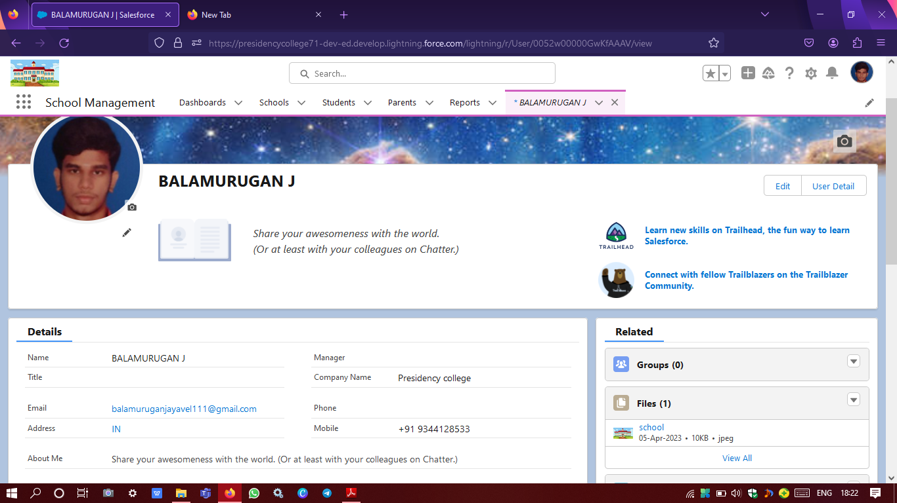

The above image contains our team leader Balamurugan’s salesforce developer account profile.

**CREATION OF OBJECTS**

Salesforce objects are database tables that permit you to store data that is specific to an organization.

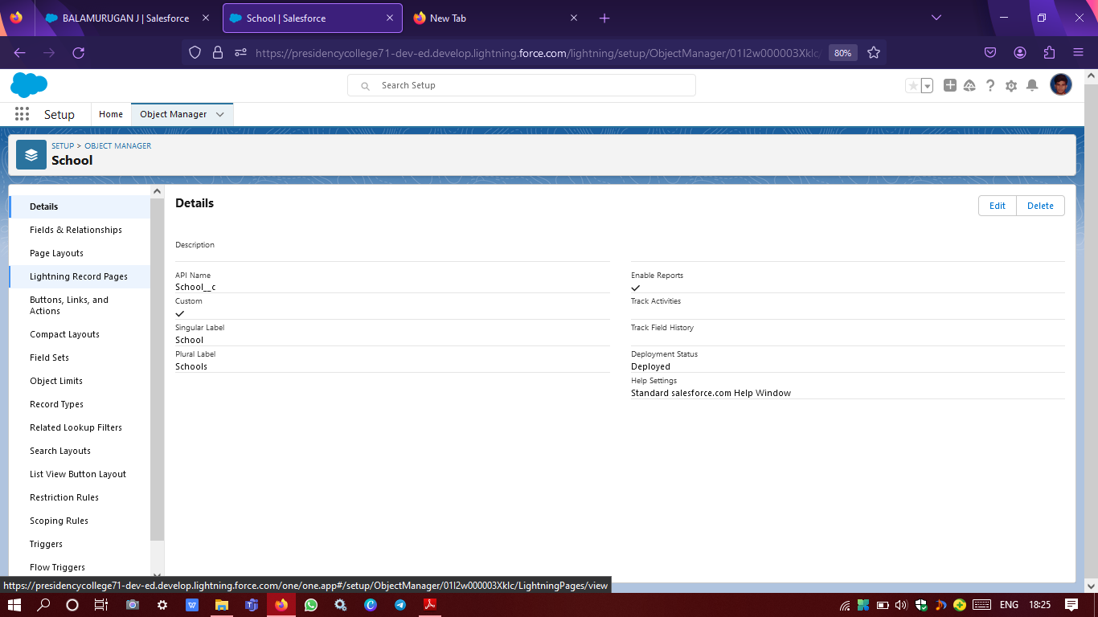

Image of created school object

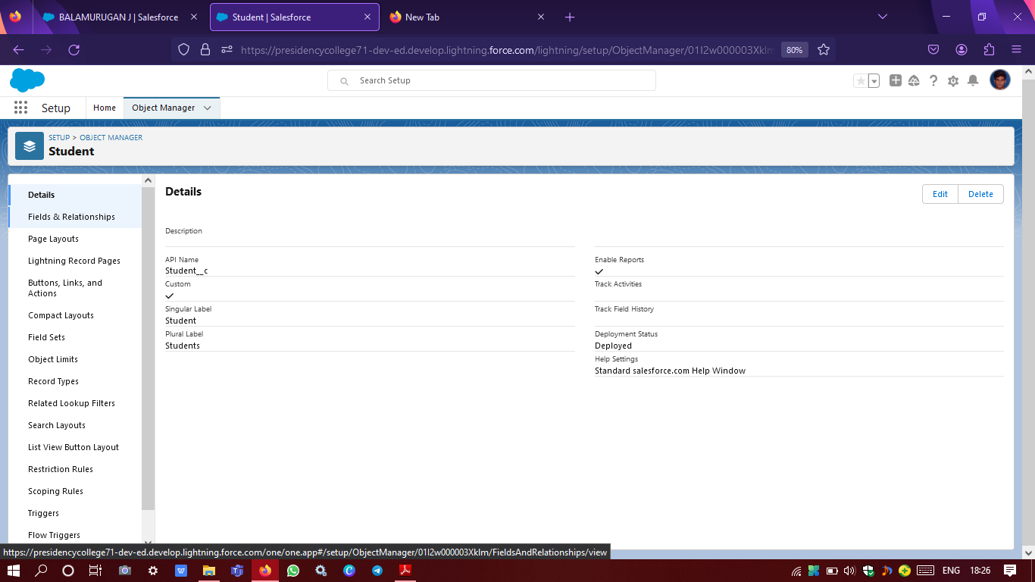

Image of created student object

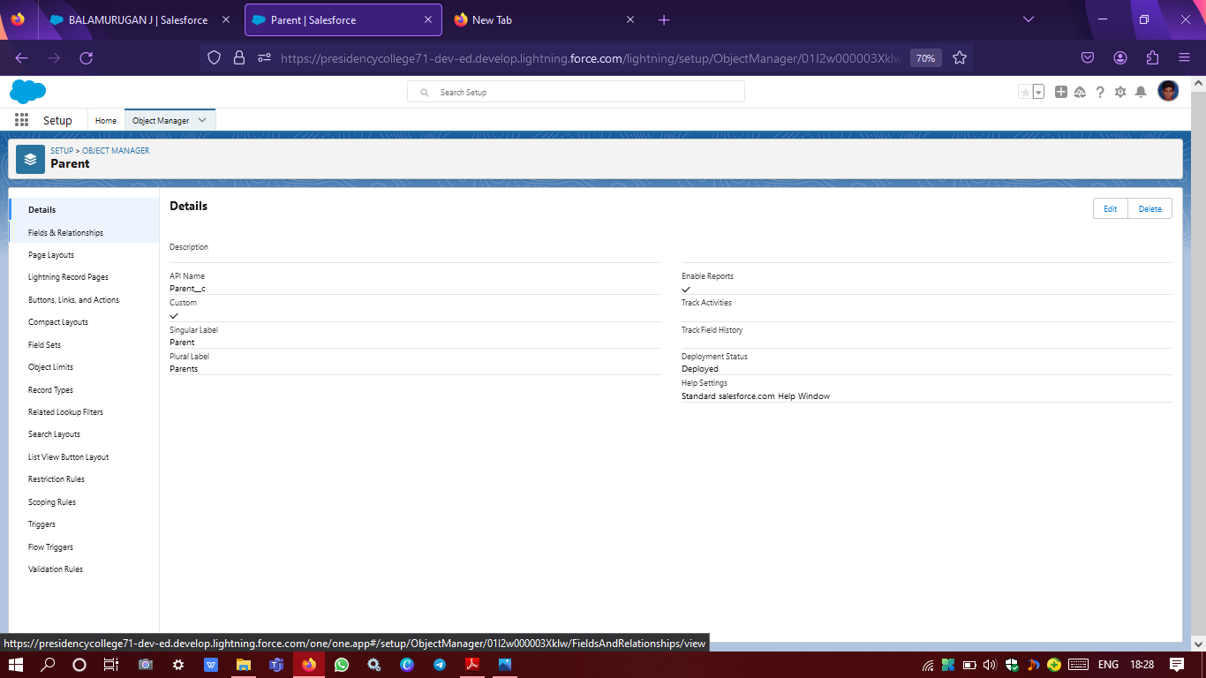

Image of created parent object

**CREATION OF FIELDS & RELATIONSHIP**

An object relationship in Salesforce is a two-way association between two objects.Relationships are created by creating custom relationship fields on an object.This is done so that when users view records, they can also see and access related data.

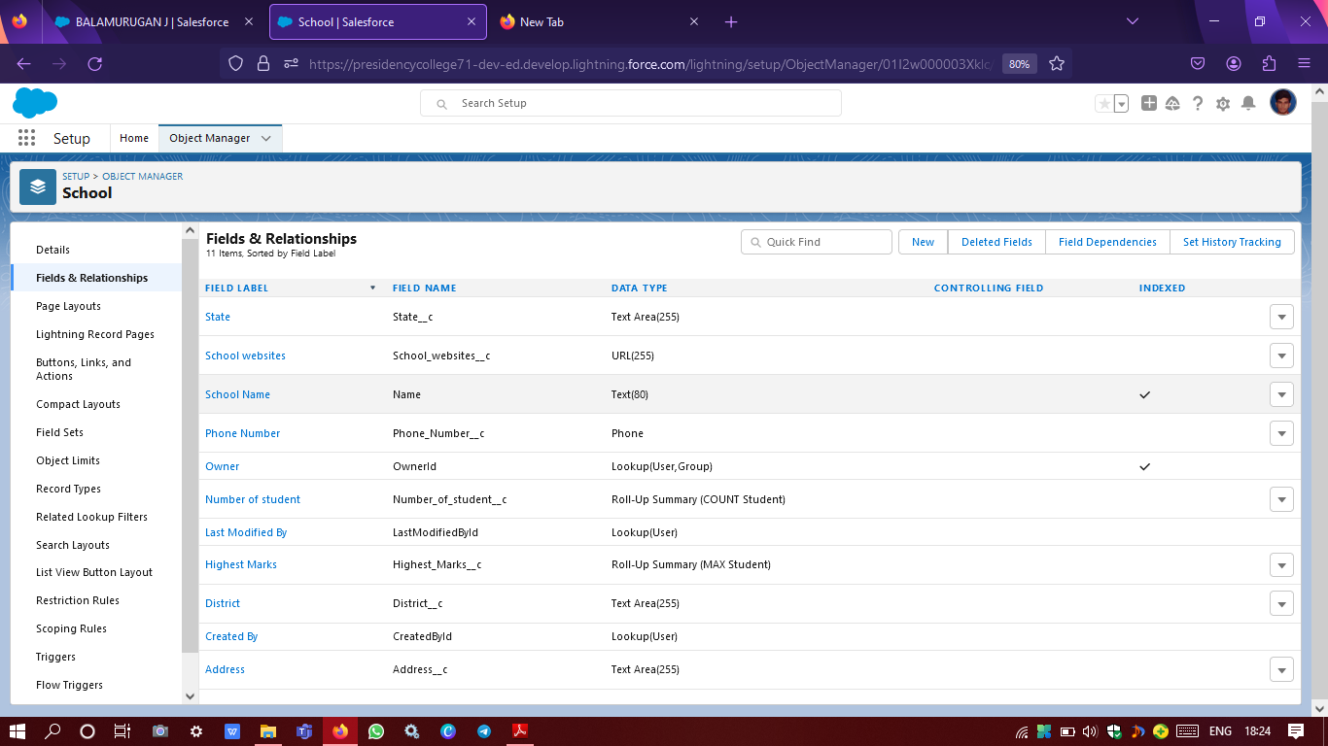

Image of created fields & relationship for school object

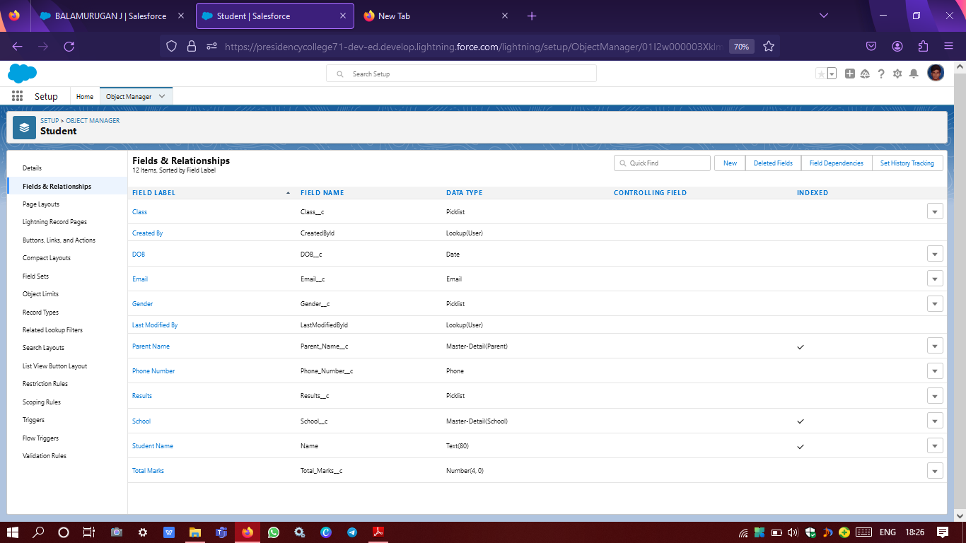

Image of created fields & relationship for student object

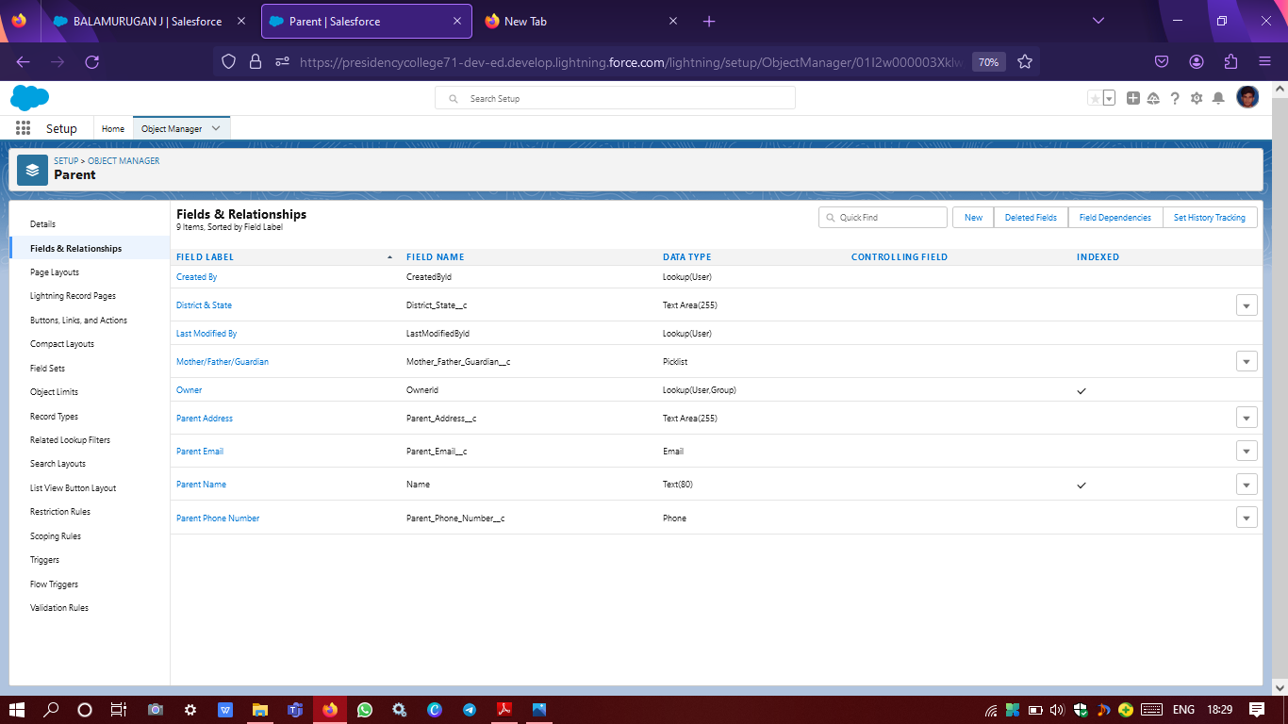

Image of created fields & relationship for parent object

**CREATION OF SCHOOL MANAGEMENT APP**

Apps in Salesforce are a group of tabs that help the application function by working together as a unit. It has a name, a logo, and a particular set of tabs.

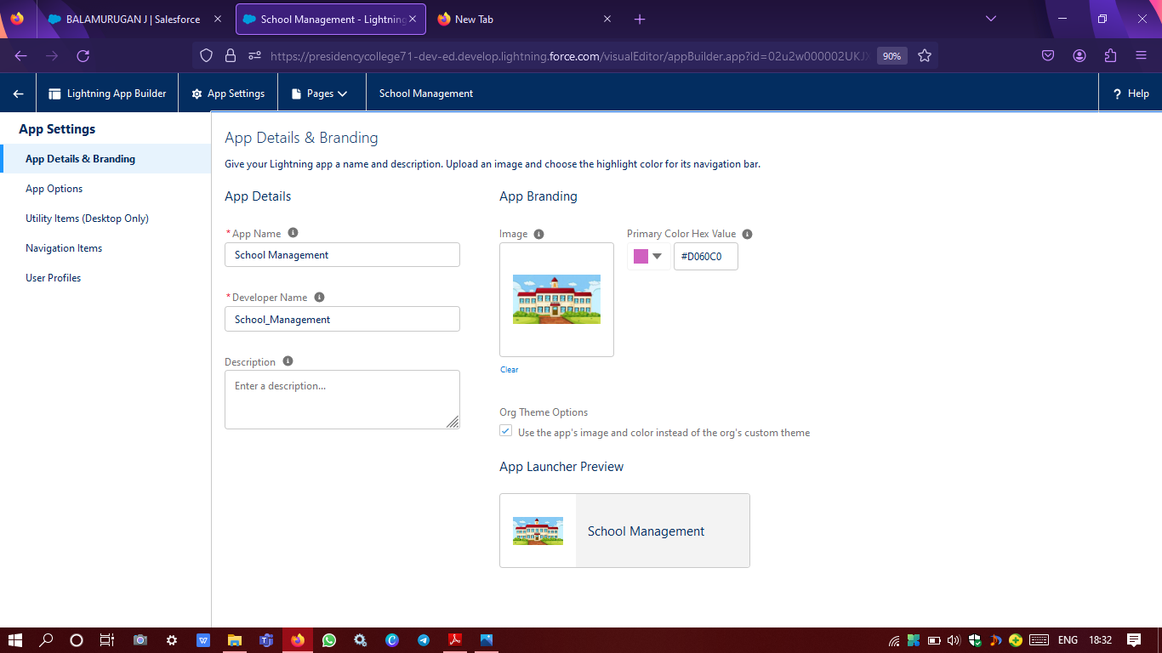

App details and branding

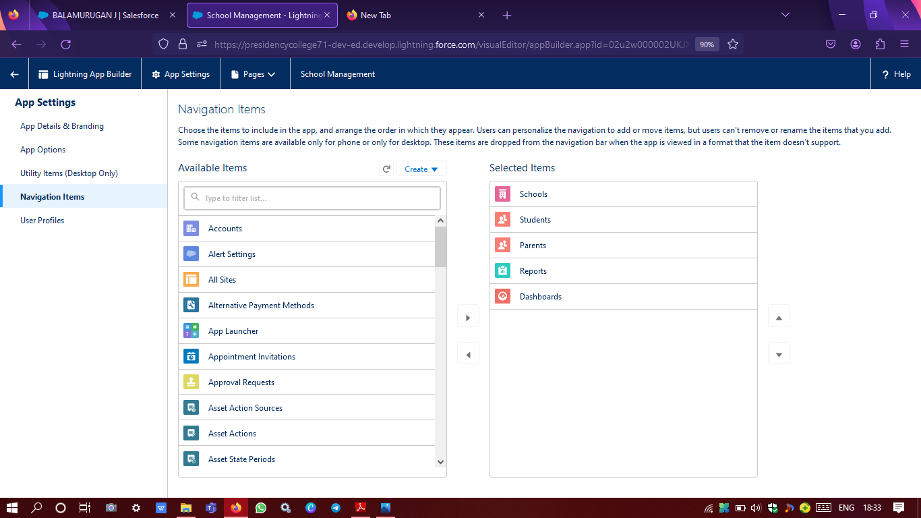

Selecting navigation items in app settings

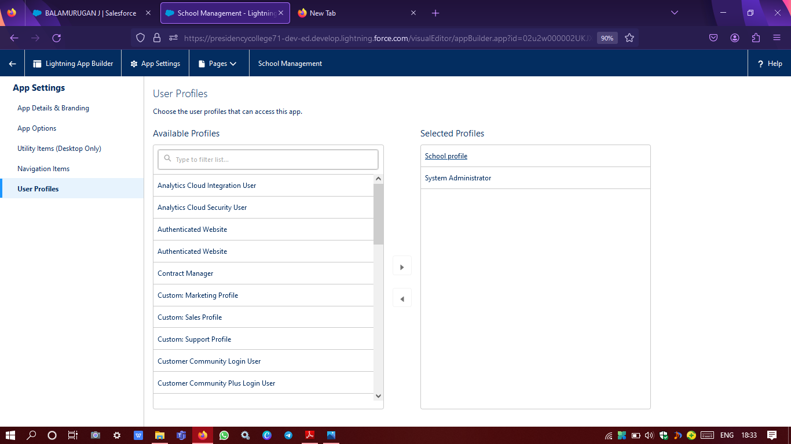

User profile selection in app settings

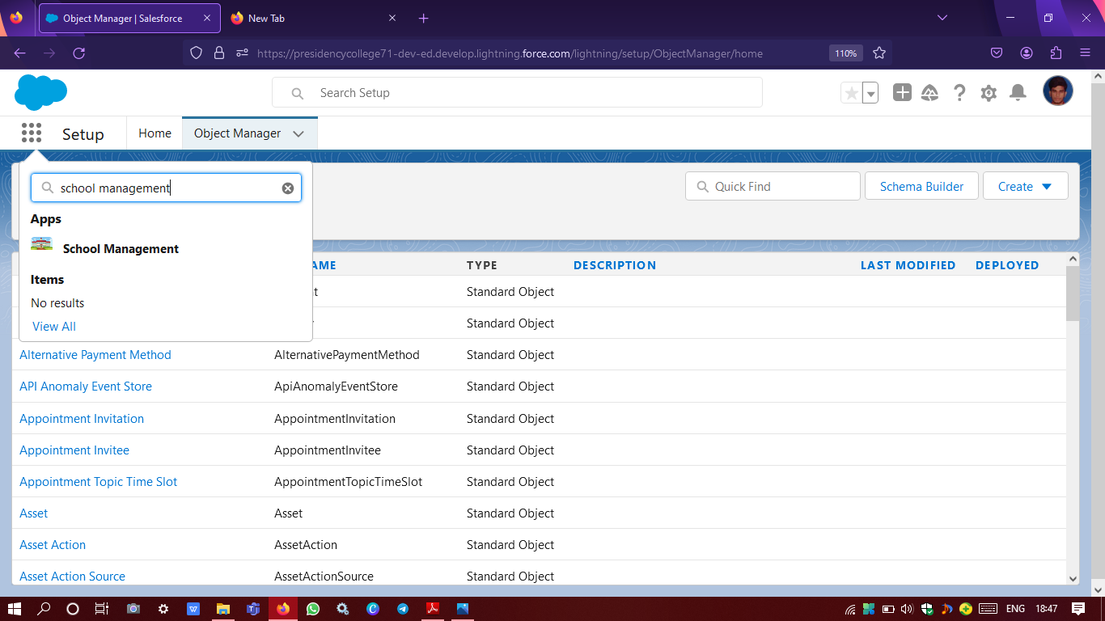

Created app available in app launcher

**PROFILE CREATION**

A profile is a group/collection of settings and permissions that define what a user can do in salesforce. A profile controls “Object permissions, Field permissions, User permissions, Tab settings, App settings, Apex class access, Visualforce page access, Page layouts, Record Types, Login hours & Login IP ranges.

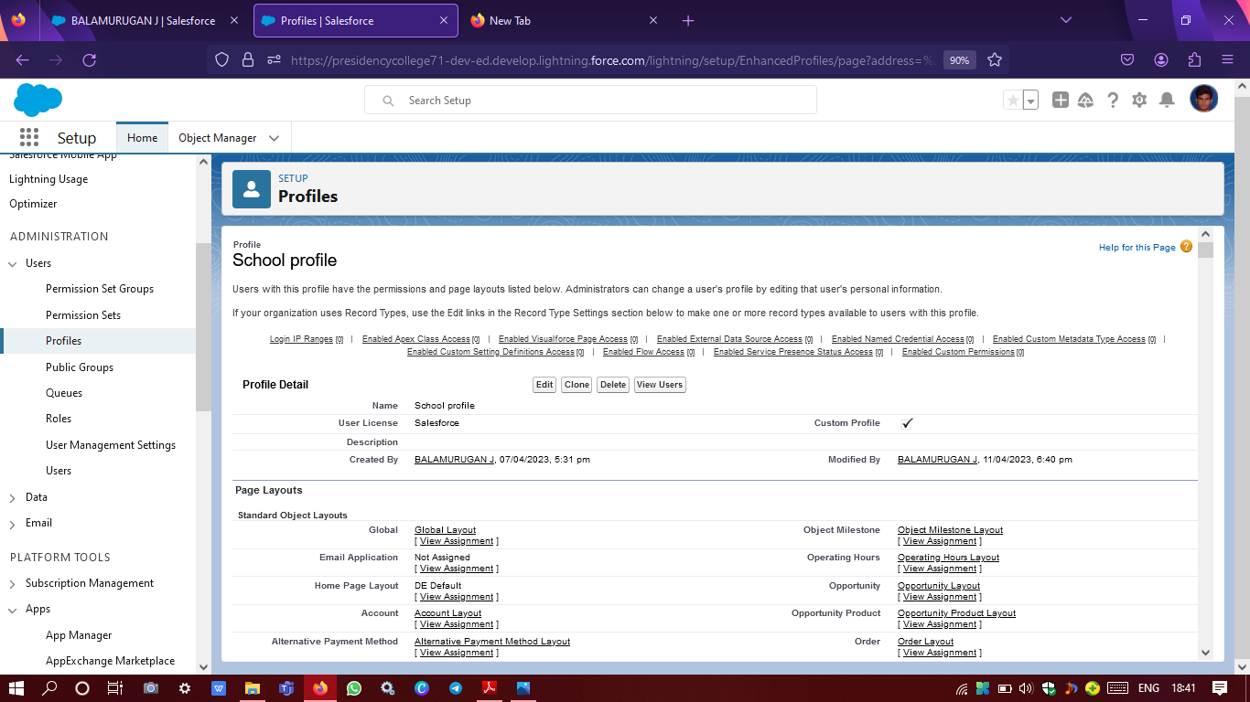

Created school profile assigned to parent profile

**USERS CREATION**

A user is anyone who logs in to Salesforce. Users are employees at your company, such as sales reps, managers, and IT specialists, who need access to the company's records. Every user in Salesforce has a user account.

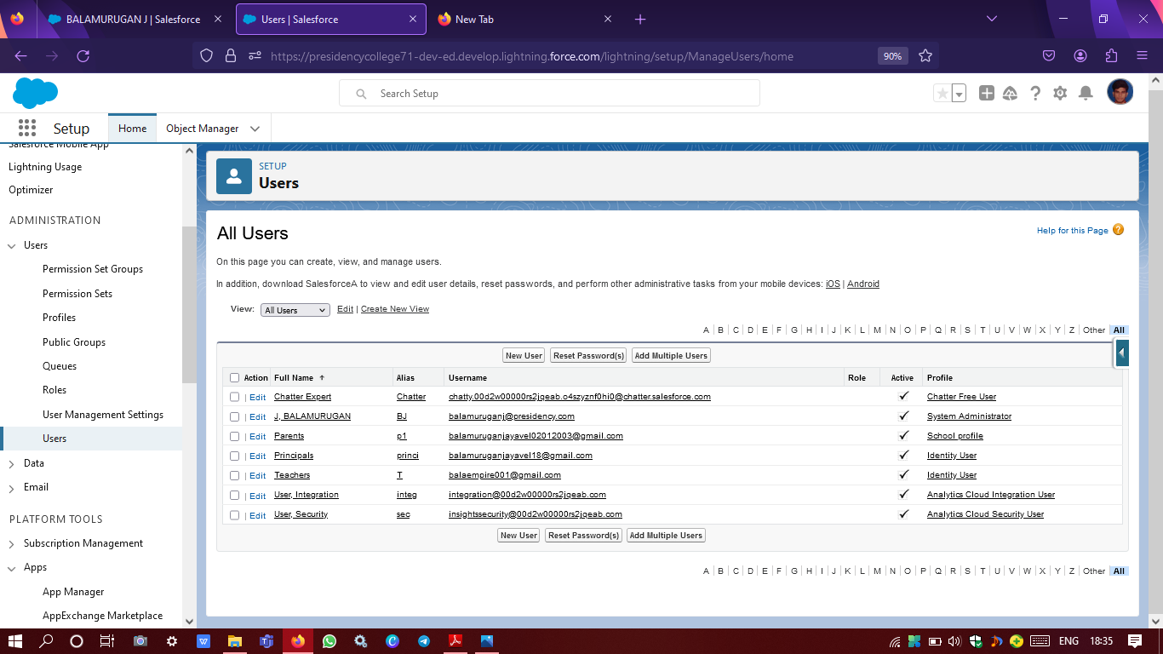

Principals, Teachers & Parents multiple user profile creation

**PERMISSION SET**

A permission set is a collection of settings and permissions that give users access to various tools and functions. Permission sets extend users' functional access without changing their profiles.

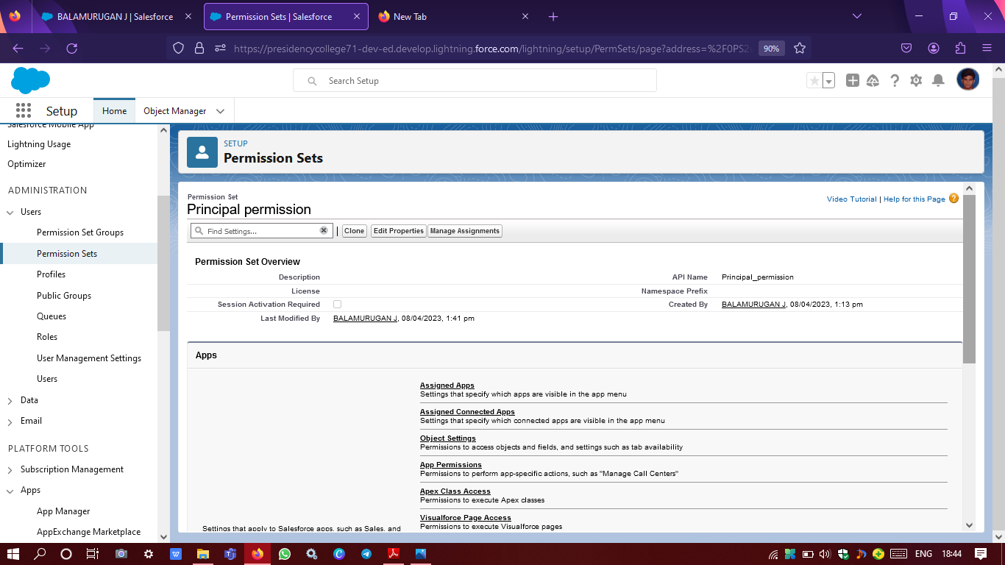

Created principal permission set

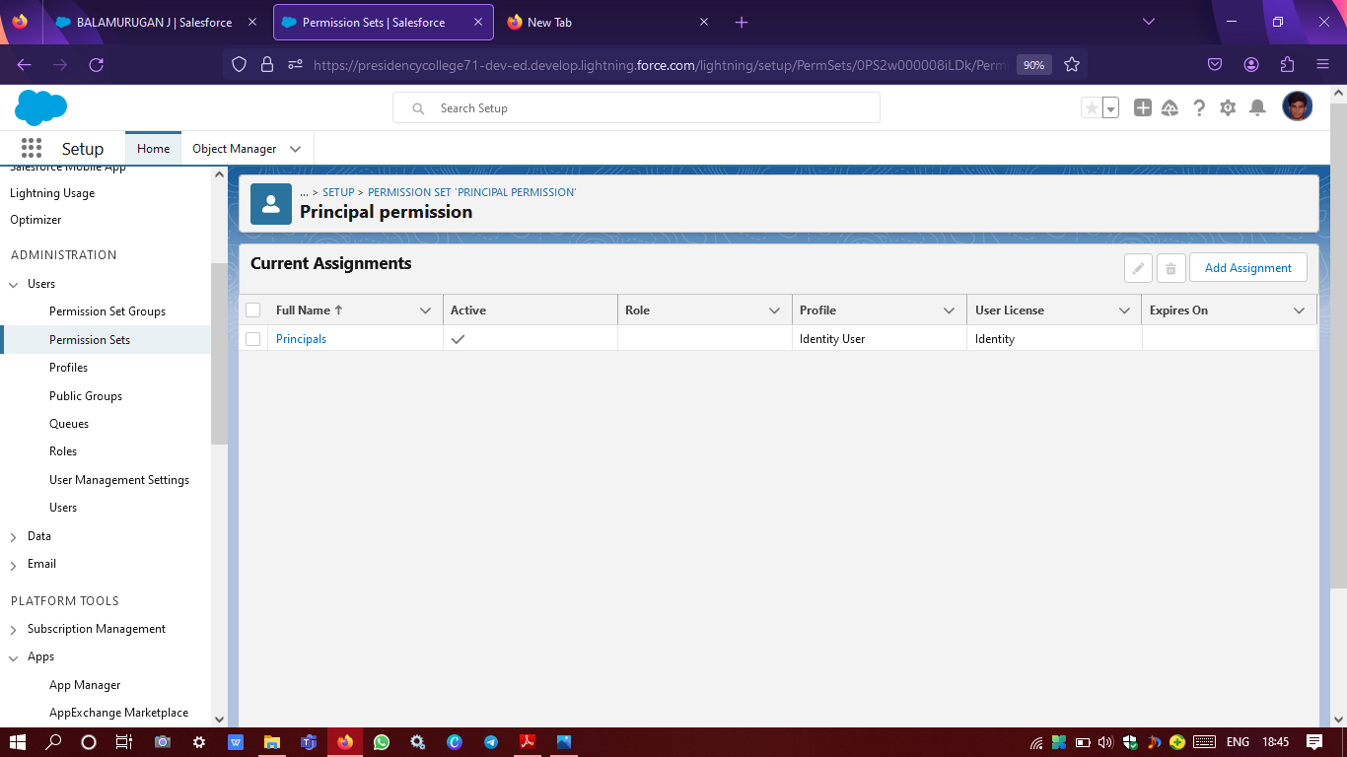

Principal permission set assigned to principals profile

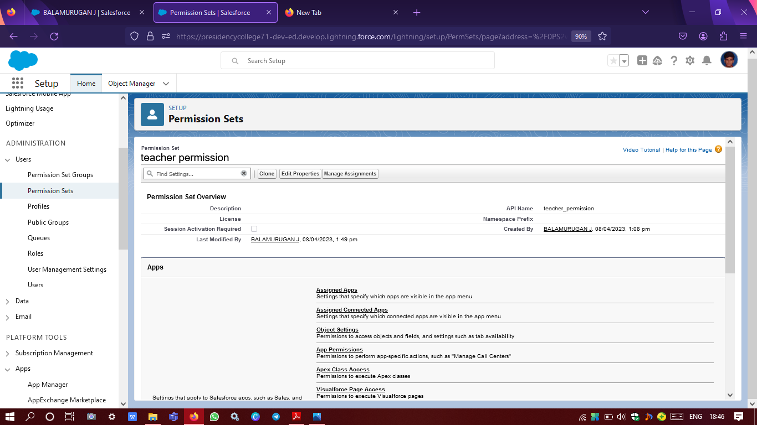

Created teacher permission set

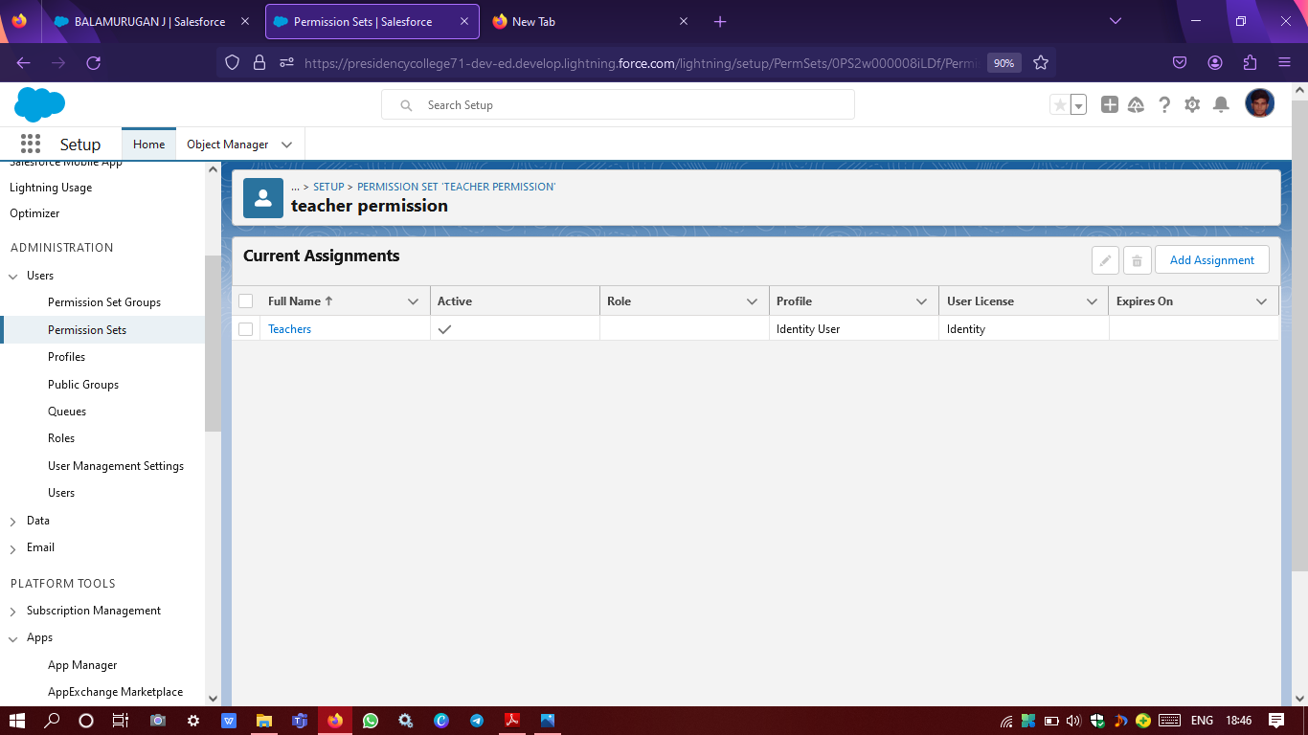

Teacher permission set assigned to teachers profile

**RESULTS**



School management application icon available in app launcher

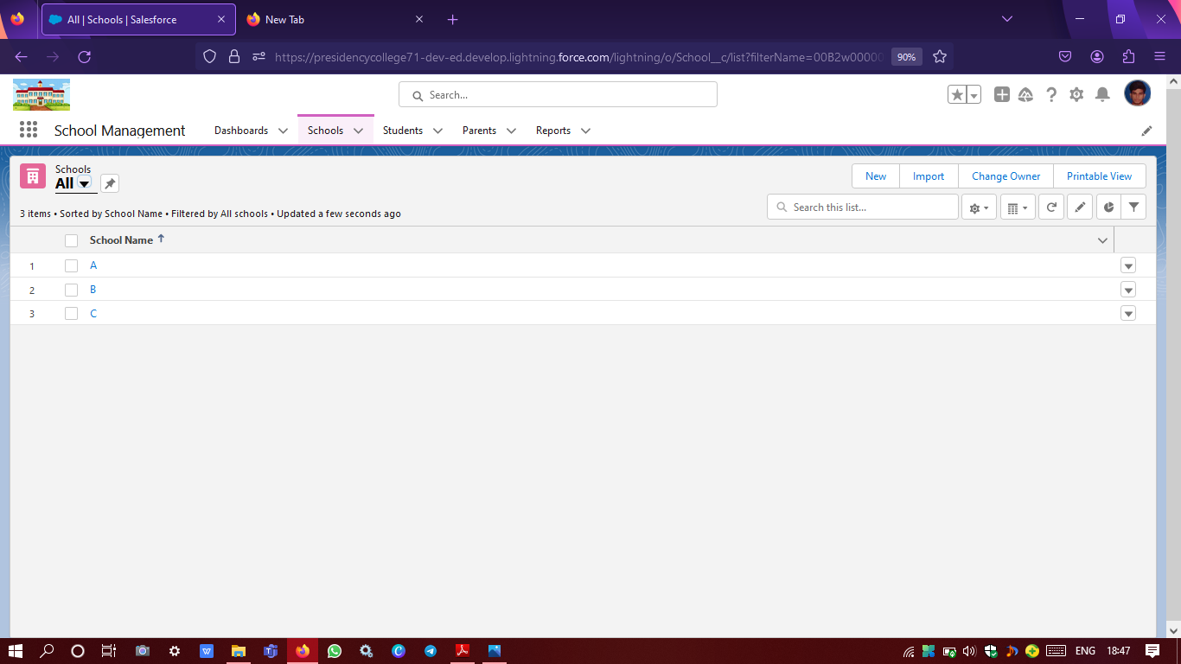

Schools tab in CMR application

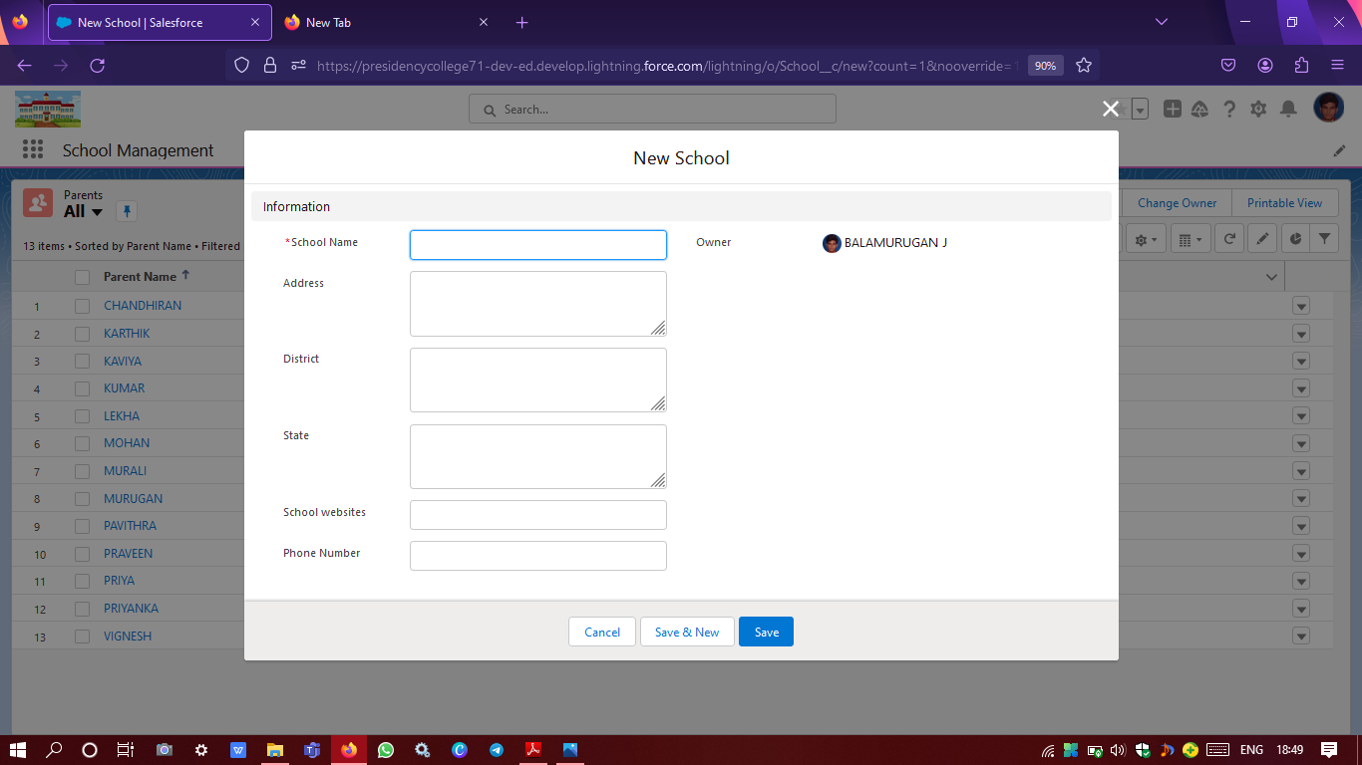

School object with fields

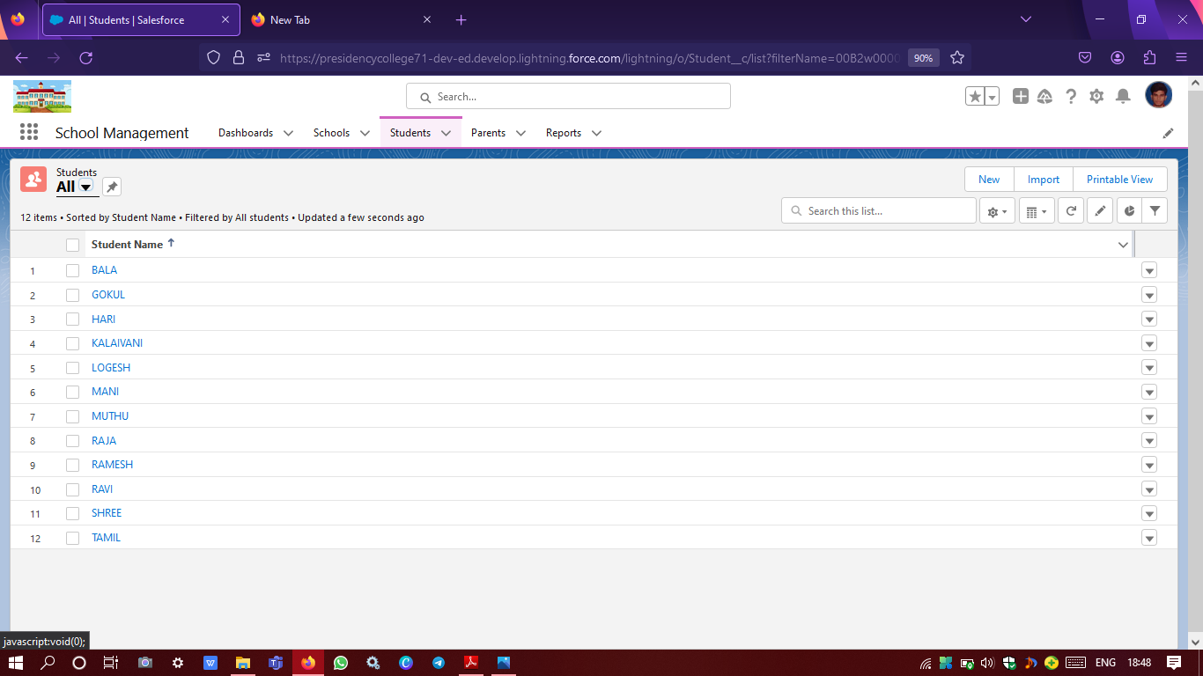

Students tab in CMR application

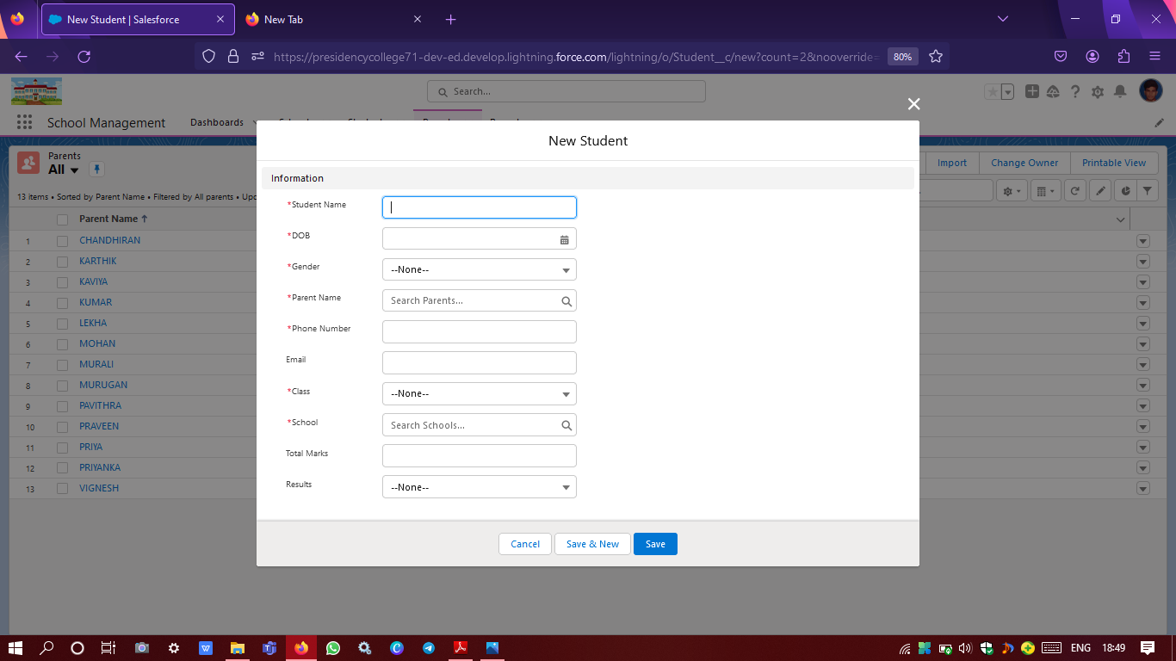

Student object with fields

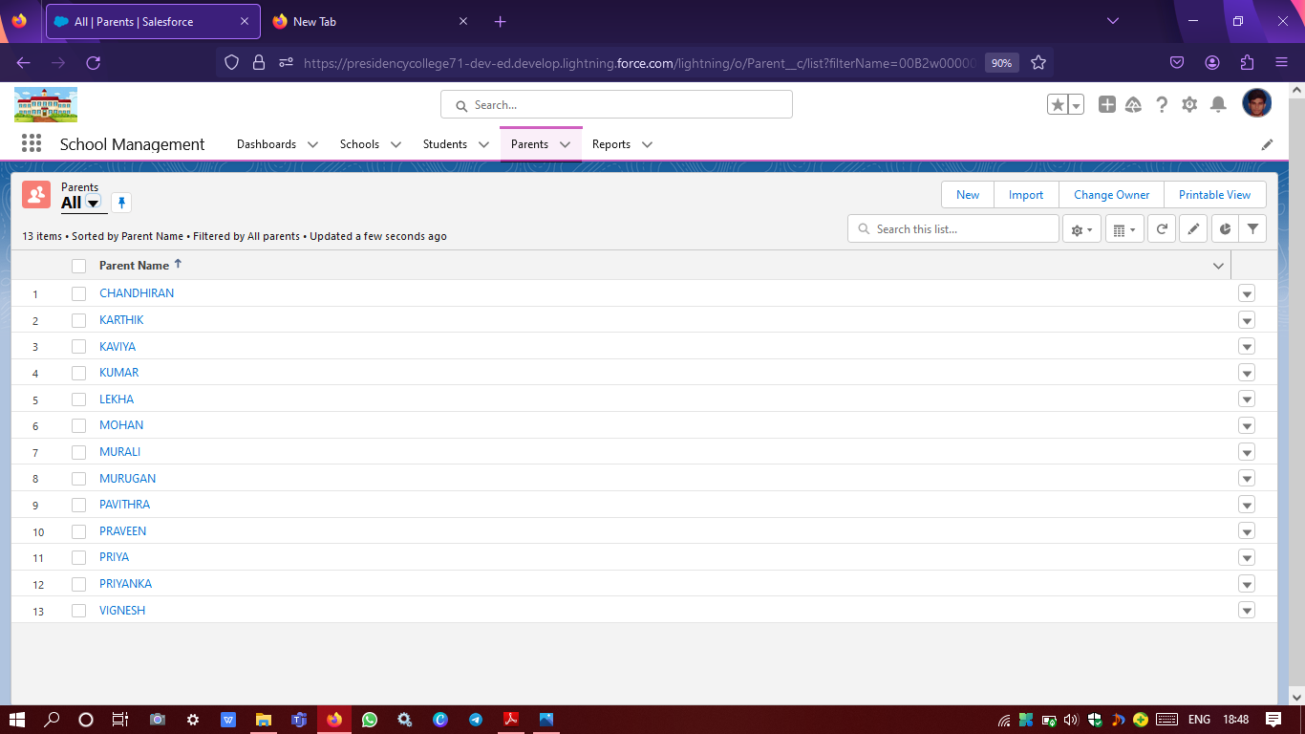

Parents tab in CMR application

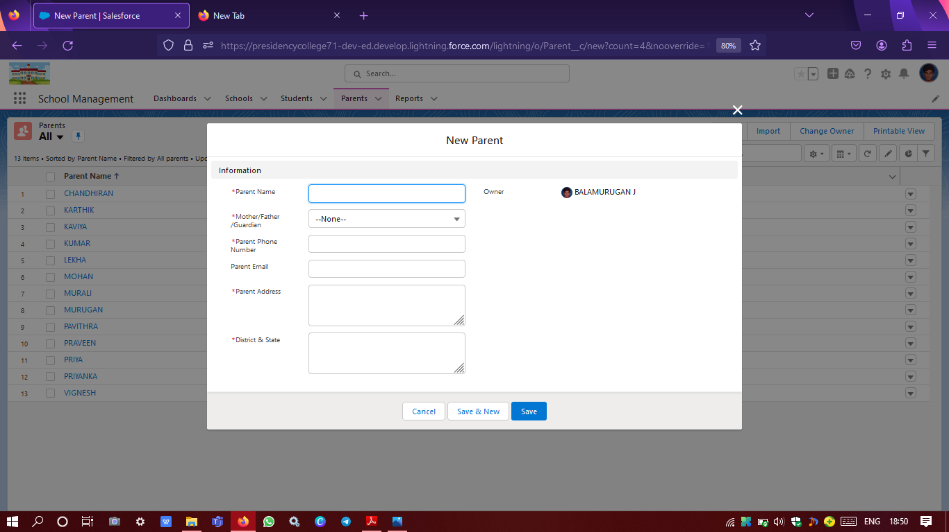

Parent object with fields

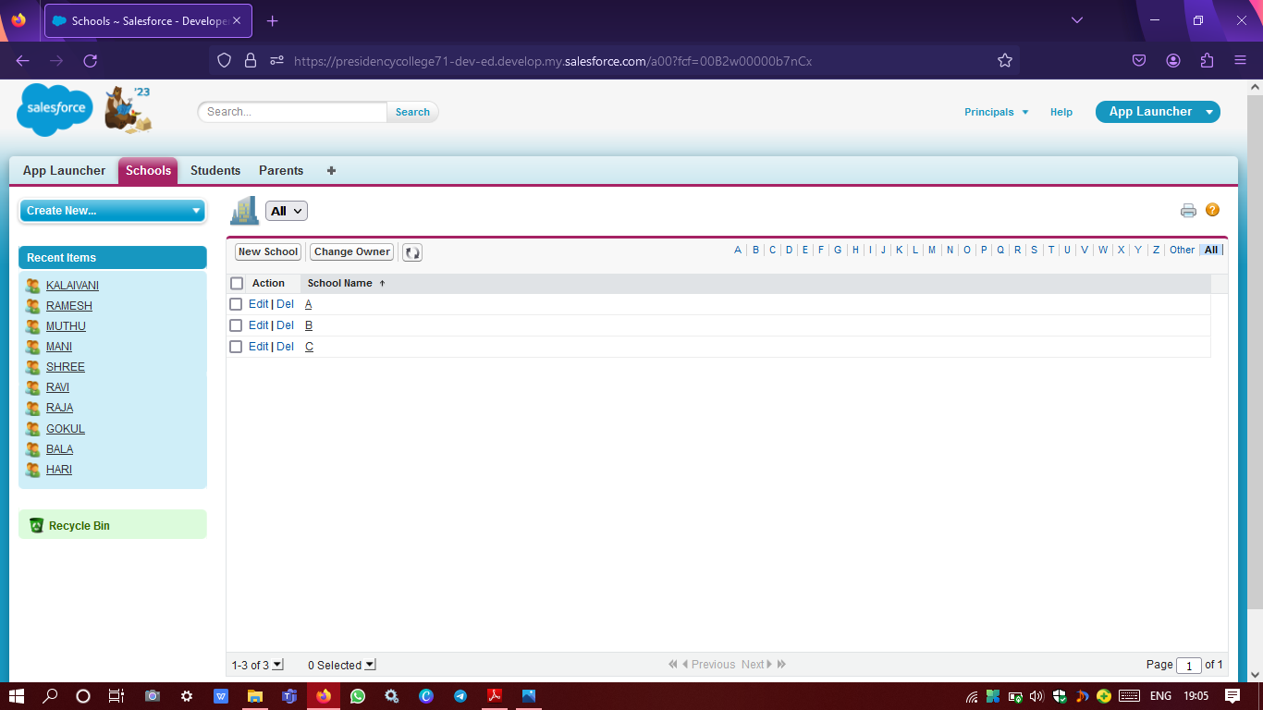

Principals user profile login

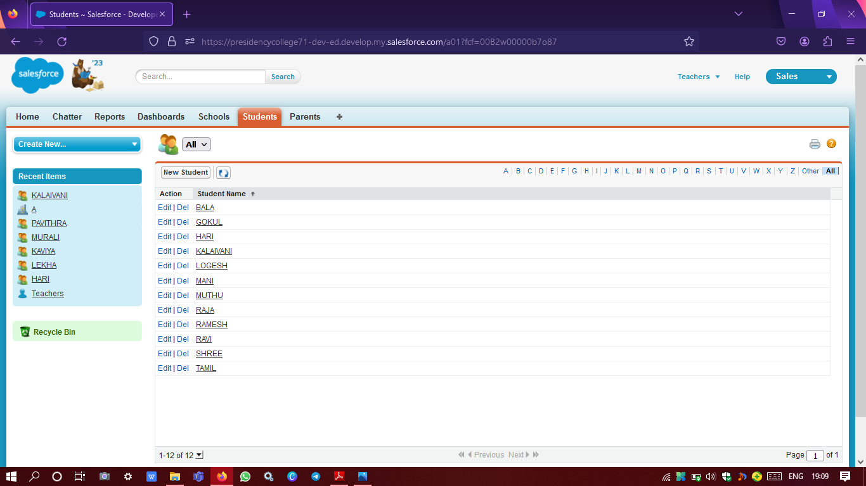

Teachers user profile login

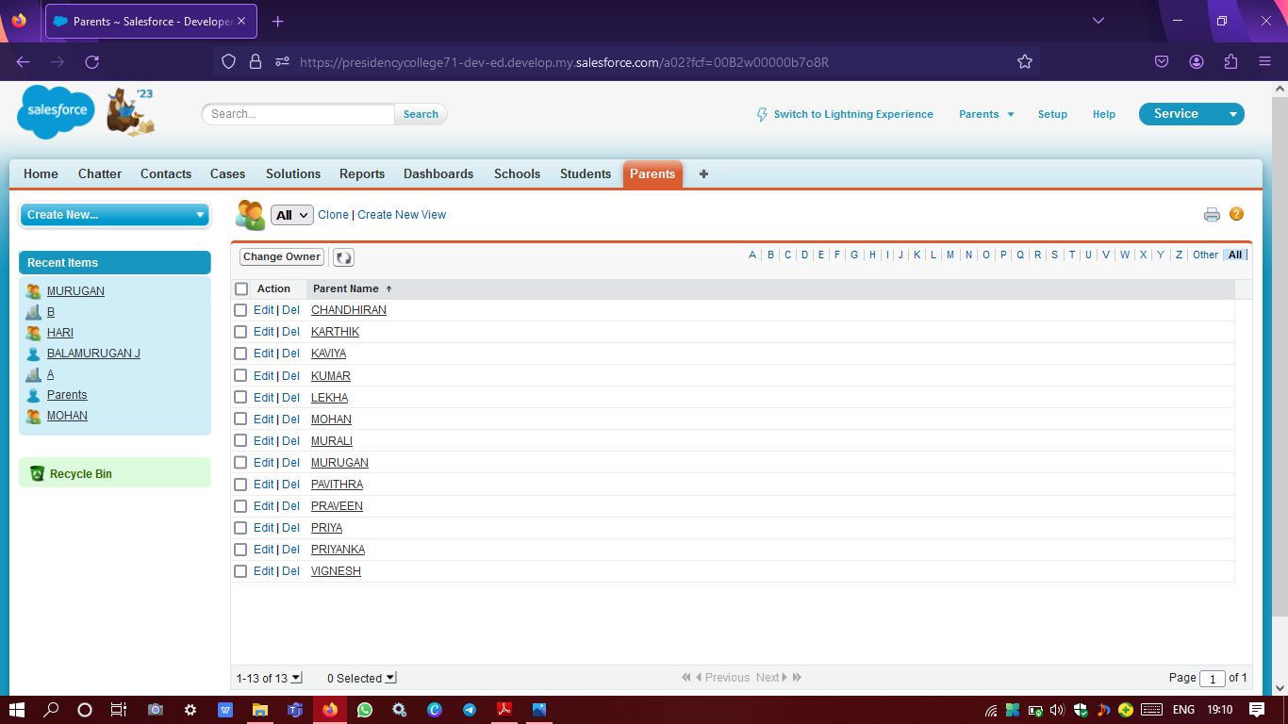

Parents user profile login

**REPORTS**

A report is a list of records that meet the criteria you define. It's displayed in Salesforce in rows and columns, and can be filtered, grouped, or displayed in a graphical chart. Every report is stored in a folder. Folders can be public, hidden, or shared, and can be set to read-only or read/write.

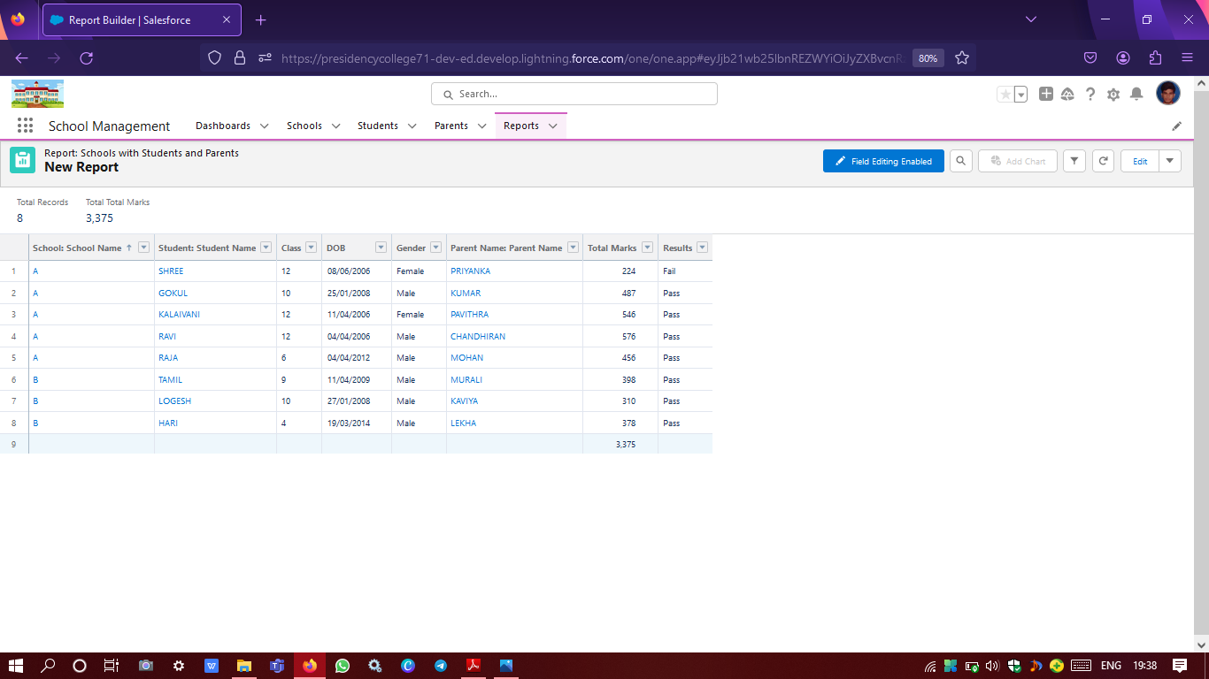

Schools with students and parents customizable report from the fake user data given for testing

## **4. TRAILHEAD PROFILE PUBLIC URL**

## Team ID:NM2023TMID06530

| **DESIGNATION** | **NAME** | **PROFILE URL** |
| --- | --- | --- |
| **TEAM LEADER** | **BALAMURUGAN J** | [**https://trailblazer.me/id/balamuruganjayavel**](https://trailblazer.me/id/balamuruganjayavel) |
| **TEAM MEMBER 1** | **HARI HARAN J** | [**https://trailblazer.me/id/harij2401**](https://trailblazer.me/id/harij2401) |
| **TEAM MEMBER 2** | **RAJASHEKAR G** | [**https://trailblazer.me/id/raja26**](https://trailblazer.me/id/raja26) |
| **TEAM MEMBER 3** | **BOOPATHY G** | [**https://trailblazer.me/id/boopa070**](https://trailblazer.me/id/boopa070) |

## **5. ADVANTAGES & DISADVANTAGES**

### **5.1 ADVANTAGES**

* Customization: Developing a custom CRM application using Salesforce allows for a high degree of customization, ensuring that the application meets the specific needs and requirements of educational institutions.The project we developed is a CMR application with that educational institutes can manage some important data of schools, students & parents.We can customize this project to next level based on requirement.
* Automation: The CRM application can automate and streamline processes such as lead management, recruitment, and admissions, reducing administrative burden and improving efficiency.
* Improved communication: The CRM application can provide a centralized platform for communication, enabling personalized communication with students and other stakeholders, leading to better engagement and relationships.
* Reporting and analytics: The CRM application can provide effective reporting and analytics tools to monitor and evaluate student and stakeholder interactions, enabling data-driven decision-making and continuous improvement.
* Cloud-based: Salesforce's cloud-based platform provides scalability, security, and performance, ensuring that the application can handle large volumes of data and users.

### **5.2 DISADVANTAGES**

* Cost: Developing a custom CRM application using Salesforce can be costly, requiring significant investment in development and customization.
* Learning curve: Using Salesforce to develop a custom CRM application may require a steep learning curve for users and developers, which can result in longer implementation times and training requirements.
* Complexity: Customizing a CRM application using Salesforce can be complex, requiring technical expertise and experience, which can be challenging for educational institutions without dedicated IT resources.
* Integration: Integrating the custom CRM application with other systems and applications used by educational institutions can be challenging, requiring additional development and customization.
* Data security: As with any cloud-based system, ensuring the security and privacy of sensitive data is a critical concern that requires attention and resources.

## **6. APPLICATIONS**

The application we developed is for school.We can also use it for other educational centers like colleges and tuition centers.The custom CRM application for schools and colleges developed using Salesforce can have several applications, including:

* Student relationship management: The CRM application can be used to manage the entire student life cycle, from lead management and recruitment to admissions, enrollment, and alumni engagement. It can provide a comprehensive view of each student's profile, including academic records, financial information, and engagement history.
* Alumni engagement: The CRM application can help educational institutions stay connected with their alumni and engage them effectively. It can provide a platform for alumni to update their contact information, receive personalized communication, and participate in events and campaigns.
* Donor management: The CRM application can be used to manage donor relationships and track donations. It can provide a platform for donors to make donations, receive tax receipts, and stay informed about the impact of their contributions.
* Faculty and staff management: The CRM application can be used to manage faculty and staff relationships, including recruitment, onboarding, performance management, and professional development. It can provide a centralized platform for communication, collaboration, and feedback.
* Marketing and communications: The CRM application can be used to design and execute marketing and communications campaigns, including email marketing, social media campaigns, and event management. It can provide effective segmentation, personalization, and analytics tools to improve campaign performance.

Overall, the custom CRM application can have a wide range of applications, enabling educational institutions to manage their relationships with stakeholders more efficiently and effectively. It can provide a single source of truth for student and stakeholder information, enable personalized engagement and communication, and provide effective reporting and analytics tools for continuous improvement.

## **7. CONCLUSION**

In conclusion, the development of a custom CRM application for schools and colleges using Salesforce has the potential to revolutionize the way educational institutions manage their relationships with students, faculty, staff, alumni, donors, and other stakeholders. The application can provide a centralized platform for communication, engagement, and data management, enabling more personalized and effective interactions. It can automate and streamline processes, reducing administrative burden and improving efficiency. The application can also provide effective reporting and analytics tools, enabling data-driven decision-making and continuous improvement.

While there are some disadvantages to developing a custom CRM application using Salesforce, such as cost, complexity, and integration challenges, the benefits outweigh the drawbacks. The advantages of customization, automation, improved communication, reporting and analytics, and cloud-based scalability make it an attractive option for educational institutions seeking to improve their stakeholder relationships.

Overall, the custom CRM application for schools and colleges using Salesforce is an innovative solution that has the potential to transform the education industry, enabling institutions to provide a more personalized and engaging experience to their stakeholders, while improving efficiency and effectiveness.

## **8. FUTURE SCOPE**

The future scope of the custom CRM application for schools and colleges using Salesforce is significant. Some potential areas of development include:

1. Artificial Intelligence: Incorporating AI-powered chatbots and machine learning algorithms to automate routine tasks and provide personalized support to stakeholders.
2. Integration: Integrating the CRM application with other systems used by educational institutions, such as learning management systems (LMS), enterprise resource planning (ERP), and student information systems (SIS).
3. Mobile app: Developing a mobile app version of the CRM application to enable stakeholders to access their information and engage with the institution from anywhere and at any time.(Note:The CRM application we developed can also be used as a mobile application)
4. Analytics and Insights: Developing more sophisticated analytics and insights capabilities, including predictive analytics, to enable educational institutions to make data-driven decisions.
5. Social Media Integration: Integrating the CRM application with social media platforms to enable educational institutions to engage with stakeholders more effectively through these channels.